Federal Advocacy and You
Three things to know about how the AOA advocates for optometry in Washington, DC, and across the nation.
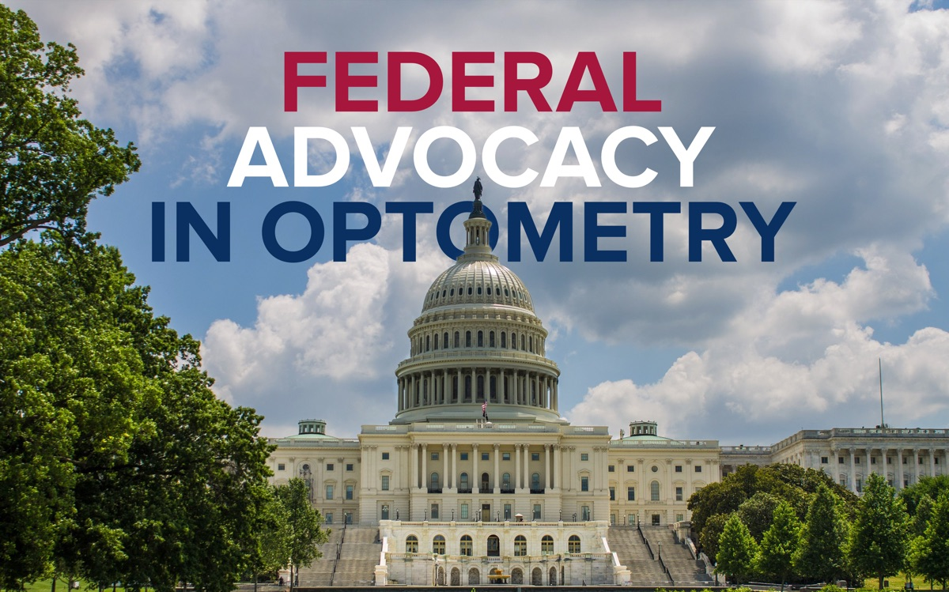
Photo by Thuan Vo on Pexels.
Understanding how optometry advocates at the federal level can serve as a model for how it advocates at the state level, the city level, and even the individual level — starting with the patient in your chair. Here are three things you need to know about how the AOA advocates for you in DC and all across the nation.

1. The Federal Keypersons Program
The Federal Keypersons Program is a network of optometrists assigned to members of Congress to build and maintain a personal and political relationship with them. By focusing on these relationships, optometry’s message carries greater weight in federal legislation. It’s the advocacy embodiment of “it’s not what you know, it’s who you know.” Over 95% of Congress is covered by this network, and when it’s time to serve patients and the profession through legislation, this program is an essential part of getting it done.
Learn more about the Keypersons Program →

2. AOA-PAC
AOA-PAC is the AOA’s political action committee. It works to elect and re-elect pro-optometry candidates to the US Senate and House, largely through donations and contributions. The PAC conducts a significant amount of research, provides generous resources, and works to be the voice of optometry in the nation’s capital.
Learn more about AOA-PAC →

3. AOA FAR
AOA FAR is the Federal Advocacy Representatives program. Each state has at least one FAR who serves as a resource for all things AOA federal advocacy. Optometry has a proud grassroots heritage, and these representatives help lead those efforts, connecting the state and federal levels. They also recruit and retain AOA-PAC investors.
Learn more about AOA FAR →

Your role
With these relationships, supports, and networks in place, the profession is well equipped to defend, promote, and advocate for itself. As a student, you can be a part of this: meet a Keyperson at AOA on Capitol Hill, consider giving any amount to AOA-PAC, and reach out to your FAR to learn more about state and federal advocacy.

